Simulating multifactorial experiments for educating the concepts of Design of Experiments

Abstract
One of the challenges in teaching the subject Design of Experiments is to come up with a proper numerical example. In this article, authors present a methodology to generate a numerical example for multifactorial experiments. Also, it presents a simple algorithm, which can be implemented in any programming language to generate unique models.
Keywords: design of experiments; educational tool; numeric examples;

1. Introduction
Generating examples is considered as one of the teacher’s tasks (Loewenberg Ball, Thames, & Phelps, 2008).

1.1 Heading Level-2
text text text text text text text text text text text text text text text text text text text text text text text text text text text text text text text text text text text text text text text text text text text text text text text text text text
Table 1. The capitals, assets and revenue in listed banks
 | text text text | text text text | text text
text text text text text
text text
Description for the above table.

text text text text text text text text text text text text text text text text text text text text text text text text text text text text text text text text text text text text text text text text text text text text text text text text text text
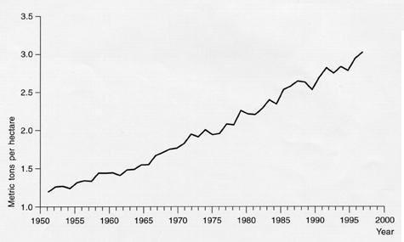
Figure 1. text text text text text.
Description for above figure. Please insert the figure into text. The figure should be high quality. Normally, 300 dpi is required.

1.1.1 Heading Level-3
text text text text text text text text text text text text text text text text text text text text text text text text text text text text text text text text text text text text text text text text text text text text text text text text text text

1.1.2 Heading Level-3
text text text text text text text text text text text text text text text text text text text text text text text text text text text text text text text text text text text text text text text text text text text text text text text text text text

2. Heading Level-1
text text text text text text text text text text text text text text text text text text text text text text text text text text text text text text text text text text text text text text text text text text text text text text text text text text

2.1 Heading Level-2
text text text text text text text text text text text text text text text text text text text text text text text text text text text text text text text text text text text text text text text text text text text text text text text text text text

2.1.1 Heading Level-3
text text text text text text text text text text text text text text text text text text text text text text text text text text text text text text text text text text text text text text text text text text text text text text text text text text
text text text text text text text text text text text text text text text text text text text text text text text text text text text text text text text text text text text text text text text text text text text text text text text text text text

5. Conclusion, Heading Level-1.
text text text text text text text text text text text text text text text text text text text text text text text text text text text text text text text text text text text text text text text text text text text text text text text text text text
text text text text text text text text text text text text text text text text text text text text text text text text text text text text text text text text text text text text text text text text text text text text text text text text text text

6. Acknowledgement
The research is financed by text text text text text text text text text text text text text text text text text text text text

7. References

Loewenberg Ball, D., Thames, M. H., & Phelps, G. (2008). Content Knowledge for Teaching. Journal of Teacher Education, 59(5), 389-407. doi:10.1177/0022487108324554

A.B. Smith, C.D. Jones, and E.F. Roberts, “Article Title”, Journal, Publisher, Location, Date, pp. 1-10.
Jones, C.D., A.B. Smith, and E.F. Roberts, Book Title, Publisher, Location, Date pp. 20-30.

Appendix
Appendix 1. text text text text text

Appendix 2. text text text text text

Copyright Disclaimer
Copyright for this article is retained by the author(s), with first publication rights granted to the journal.
This is an open-access article distributed under the terms and conditions of the Creative Commons Attribution license (http://creativecommons.org/licenses/by/4.0/).

Double-Blind Peer Review Guidelines

This journal uses double-blind review, which means that both the reviewer and author identities are concealed from the reviewers, and vice versa, throughout the review process.
To facilitate this, authors need to ensure that their manuscripts are prepared in a way that does not give away their identity. To help with this preparation please ensure the following when submitting to IJIER:
- Submit the Title Page containing the Authors details and Blinded Manuscript with no author details as 2 separate files.
Information to help prepare the Title Page
This should include the title, authors' names and affiliations, and a complete address for the corresponding author including telephone and e-mail address.
Information to help prepare the Blinded Manuscript
Besides the obvious need to remove names and affiliations under the title within the manuscript, there are other steps that need to be taken to ensure the manuscript is correctly prepared for double-blind peer review. To assist with this process the key items that need to be observed are as follows:
- Use the third person to refer to work the Authors have previously undertaken, e.g. replace any phrases like “as we have shown before” with “… has been shown before [Anonymous, 2007]”.
- Make sure figures do not contain any affiliation related identifier
- Do not eliminate essential self-references or other references but limit self-references only to papers that are relevant for those reviewing the submitted paper.
- Cite papers published by the Author in the text as follows: ‘[Anonymous, 2007]’.
- For blinding in the reference list: ‘[Anonymous 2007] Details omitted for double-blind reviewing.’
- Remove references to funding sources
- Do not include acknowledgments
- Remove any identifying information, including author names, from file names and ensure document properties are also anonymized.

How to Remove the Hidden Personal Information Microsoft Office
View and Remove Hidden Data
On Office 2013, Office 2013 or Office 2010, click the File menu, click Info and the Inspect Document tool will be front-and-center, informing you about the potentially sensitive information that the document contains. This information is more obvious than it is in older versions of Office, but it’s still easy to miss if you’re not aware Office adds this sensitive data to your documents.

On Office 2007, click the Office orb button on the ribbon, point to Prepare, and click Inspect Document.
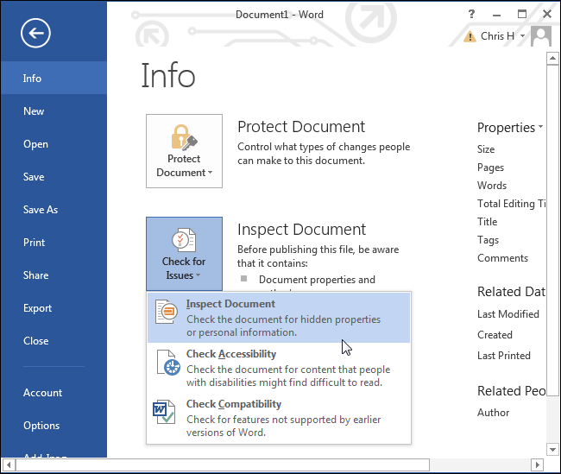
To view the hidden metadata in the document, click the Check for Issues button, click Inspect Document, and choose the types of metadata you want to examine the document for. You can just leave all the options selected to examine the document for all types of metadata.
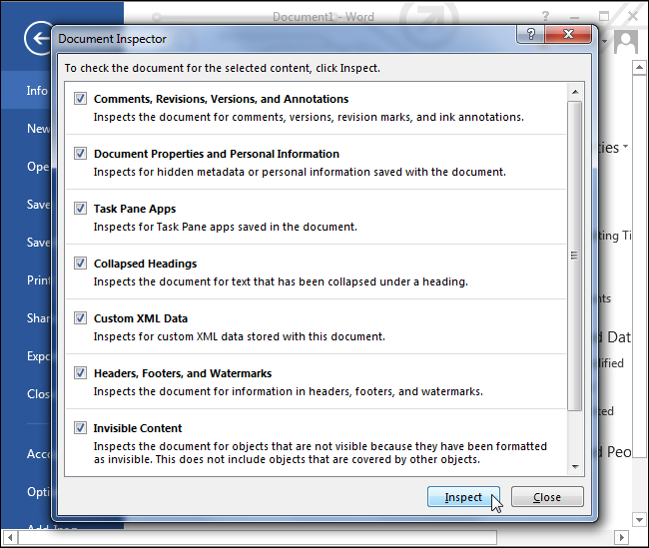
Click Inspect and Office will examine the document for metadata. Click the Remove All button next to a type of metadata to remove it.
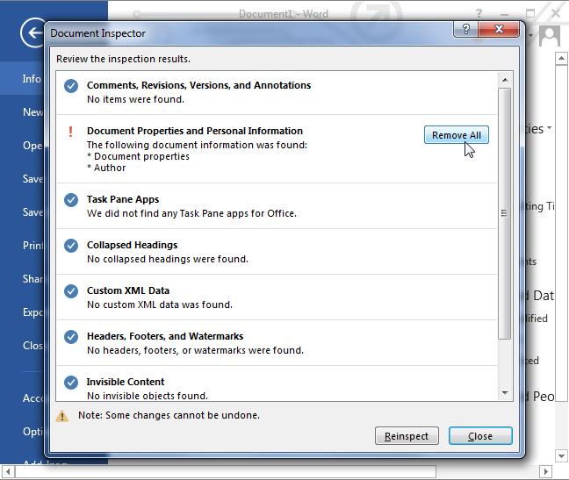
Note that you won’t be able to recover most of this metadata after deleting it. For this reason, Microsoft recommends creating a new copy of the document (use the Save As feature) before removing the metadata and publishing the document. You’ll then have a copy of the document with the metadata. Of course, if you don’t want this metadata at all, you can just remove it without worrying about preserving a copy.

How to Stop Office from Saving Metadata
Unfortunately, you’ll have to use the Document Inspector tool to remove sensitive data from each individual document before you publish or share it with someone. There’s no built-in way to remove this information from multiple documents at once, nor is there an Office-wide setting to prevent Office from applying this data to documents.
However, you can have Office automatically remove the metadata every time you save a file. You must apply this setting to each document you use — it’s a document-specific setting, not a system-wide setting.
To prevent Office from saving metadata along with your documents, click the File menu, click Options, and select the Trust Center category. Click the Trust Center Settings button and select Privacy Options. Enable the “Remove personal information from file properties on save” option. If it appears grayed out, click the Document Inspector button below, run the Document Inspector, and remove all the document’s personal information. You should then be able to click the checkbox.

Remember, you’ll have to change this option this for each document separately.
